OPPRESSION AND RESISTANCE
History Graduate Student Association,
Florida State University presents

2017 Southeast Regional
Graduate Student Conference

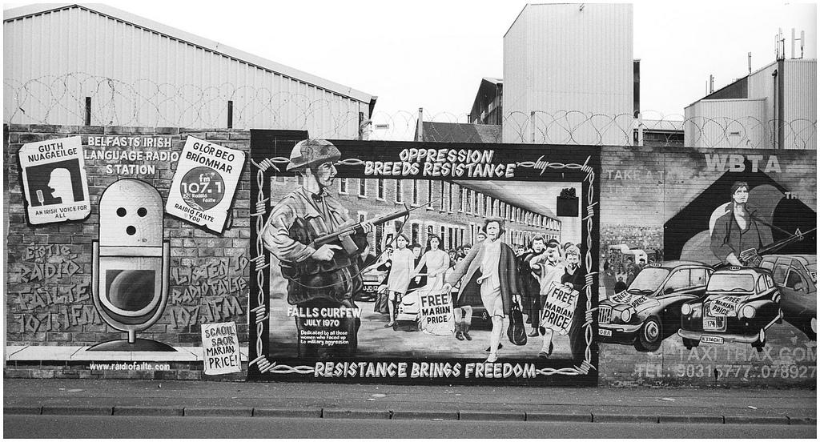

9th Annual Southeast Regional Graduate Student Conference
3 March 2017

Schedule of Events

12:00 - 12:30
Registration
***
12:30 - 1:40
First Session
***
1:55 - 3:05
Second Session
***
3:20 - 4:30
Third Session
***
5:00 - 6:00
Dinner served in Claude Pepper Center
***
6:00 - 7:30
Keynote Speech in Claude Pepper Center

[See map at end of program]

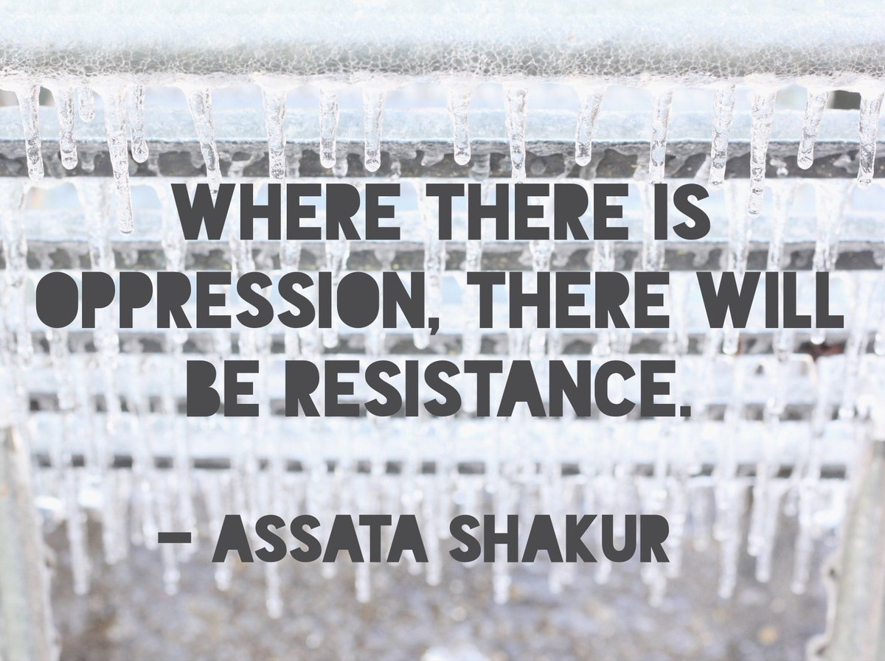

12:30 - 1:40

Room 1: Subversive Resistance in Wartime
Dr. Charles Upchurch
- Creating Narratives of Oppression and Resistance in the French Revolution: The Freedom of Religion under Revolutionary and Napoleonic Regimes
Joseph P. Harmon, Florida State University
- Becoming Spies: British Women’s Act of Resistance Against Societal Restrictions
Danielle Wiransky, Florida State University

Room 2: Policing Resistance
Dr. G. Kurt Piehler
- “Out of the Mouths of Babes Come Words of Wisdom:” Sheriff Jim Clark Answers to Northern Children for his Violence in Selma, Alabama, 1965
Lewis Wheldon, Rutgers University - Camden
- Overcoming Civil Rights Oppression: Historical Research on Convict Labor at Parchman Penitentiary
Joc Calloway, University of West Florida

Room 3: The Art of Resistance
Dr. Jennifer Koslow
- Casting Character: An Examination of Crafted Memory in Bronze Legacy Statues at Florida State University
Lydia Nabors, Florida State University
- Representational Love Triangle of Dion Boucicault’s The Octoroon
Pedro E. Alvarado, Georgia State University
- Making Light of Dark Subjects: Humor and Song in Abolitionist Dramas
Taylor R. Tobias, Florida State University

1:55 - 3:05

Room 1: Female Agency in the Anglosphere
Dr. Suzanne Sinke
- Masculinity in The Memoirs of Emma Courtney and The Victim of Prejudice
Esther Stuart, Georgia Southern University
- The Gilded Cage of Frances Cleveland: The Repression and Resistance of a First Lady
Kathryn L. Beasley, Florida State University
- Land and Love: Anne Lister and Female Agency in Pre-Victorian Britain
Kimberly Myers, Florida State University

Room 2: Enslaved Minds and Bodies
Dr. Maxine Jones
- Subversive Affirmation: Freedom Suits, Carnival, and the Grotesque Body
James N. McAllister, Florida State University
- The Role of Slavery “Insanity” in Plantation Culture
Kristi Simon, Florida State University
- The Consequences of Empire: Slavery and the Dutch Reformed Church in New Netherland
Justin R. Vos, Florida State University

3:20 - 4:30

Room 1: Native Resistance Then and Now
Dr. Robinson Herrera
- Native American Trade as an Early Act of Resistance to Colonial Intrusion
S. Andrew Wise, Florida State University
- Energy Development: Turmoil on Reservations
Kathie L. Beebe, Florida State University

Room 2: Oppressive Violence and Violent Resistance
Dr. Michael Creswell
- Foundations of Abolition: The Partnership of the Royal Navy and British Imperial Administration in the Early Interdiction of the Slave Trade
Matthew McLin, Florida State University
- School of the Americas Watch: International Resistance to Oppression
Jorge Oseguera Gamba, Florida State University
- American Cross-Cultural Ignorance and the Failure of COIN in Iraq and Afghanistan: An Interdisciplinary Appeal for Counterinsurgency Policy Reform
Ryan David Marr, East Carolina University

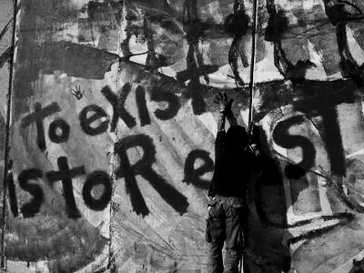

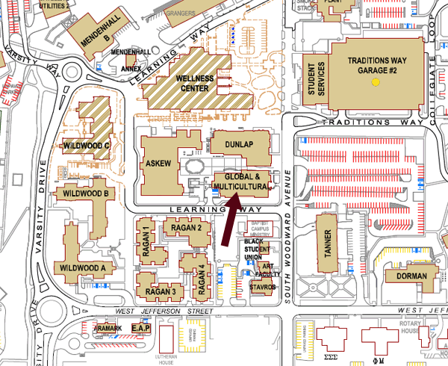
Global and Multicultural Engagement Building

Claude Pepper Center

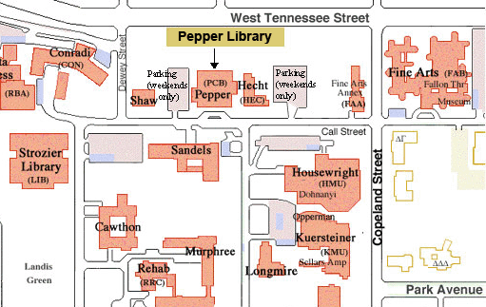
Special Thanks to:

